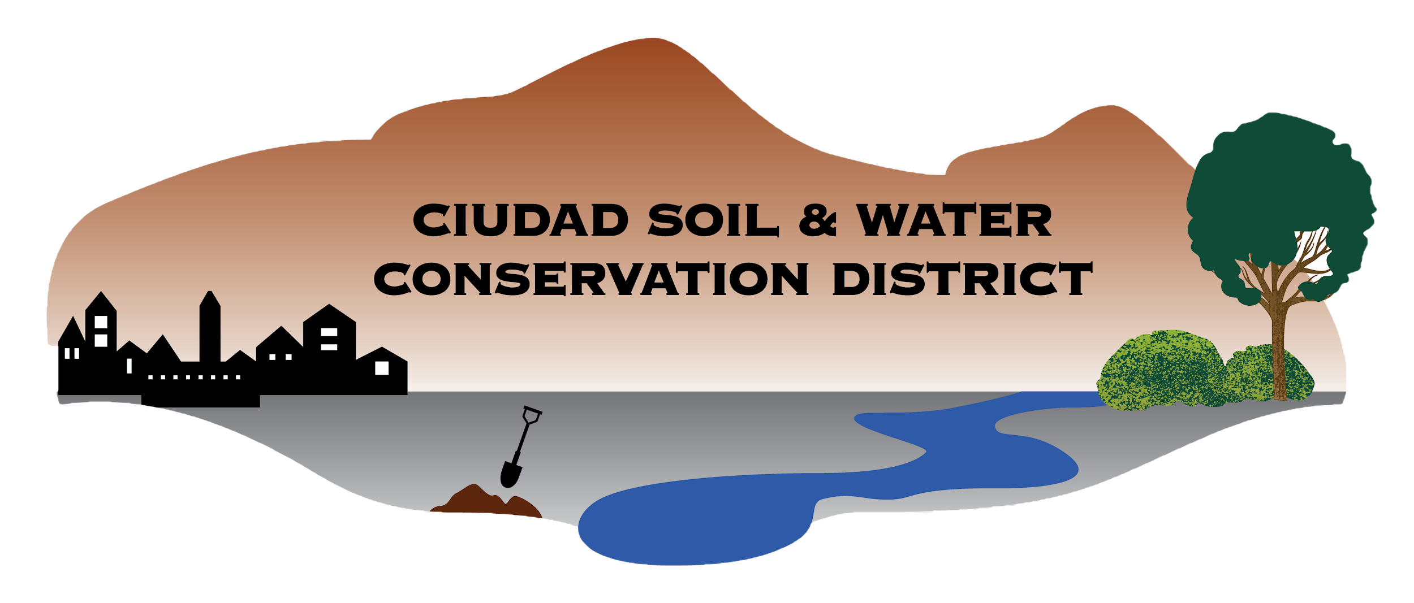

Ciudad Soil and Water Conservation District
100 Sun Ave NE Room 160
Albuquerque, NM 87109
505-510-3478

CIUDAD SOIL AND WATER CONSERVATION DISTRICT
BOARD OF SUPERVISORS MEETING
Zoom
Virtual Meeting

March 26, 2026
DRAFT
Meeting Minutes

- Call to Order 4:31 pm
  - Supervisors present: Attendance confirmed by roll call. A Quorom was present.

Roll call: Steve Glass: Present
Tom Allen: Present
Ramona Goolsby: Present
Maria Young: Present
Gabriella Coughlin: Present
Daniel Conklin: Present
Sarah Hurteau: Not Present Arrived 4:38

  - Supervisors Absent:
  - Others Present: Joshua O’Halloran, Erin Blaz, Zane Conklin, Michael G, Marie Booth, Zoe Economou, Charlene Pystoky

- Agenda for 3/16/2026 Review and Approval (Action Item): Dan Conklin moved to approve the 3/16/2026 agenda. Seconded by Tom Allen and approved unanimously by roll-call vote.
Steve Glass: Yes
Tom Allen: Yes
Ramonda Goolsby: Yes
Maria Young: Yes
Gabriella Coughlin: Yes
Daniel Conklin: Yes
Sarah Hurteau: Not Present

- Review and Approval of Minutes (Action Item)
  - Review and Approval (Action Item): Tom Allen moved to approve the Draft Board Meeting minutes 2.23.26. Seconded by Dan Conklin and approved by a by roll-call vote.

Roll Call Vote:
Steve Glass: Yes
Tom Allen: Yes
Ramonda Goolsby: Abstain
Maria Young: Abstain
Gabriella Coughlin: Abstain
Daniel Conklin: Yes
Sarah Hurteau: Not Present

- Guest Presentation:
  - East Mountain High School Envirothon presentation from Zane Conklin and Marie Booth. Two teams are competing. Team leads are helping to develop a student guide for future teams, seeing growth but are hoping to recruit future students. Zane provided an overview for how the Envirothon competition works. We discussed further support for the team and future teams.

- Reports of Partners
  - NMDA (Katie Mechenbier): A written report was provided. Mill Levy Resolution is due at the April 20 meeting. The board discovered that the FY27 budget meeting with staff will occur after the April 20th meeting and discussed moving the monthly board meeting to a week after April 20th so the resolution is informed by the budget meeting.
  - NRCS (Janelle Cruz): No report was provided

- Action Items
  - WUI Work Plan (Updated). This agreement is with State Forestry to do private property thinning and has been seen by the board before. This action item addresses a date change and request from State Forestry for final signature. Tom Allen made a motion to approve Steve Glass’s signature on the agreement on behalf of the board. Seconded by Sarah Hurteau and approved by roll call vote.

Roll Call Vote:
Steve Glass: Yes
Tom Allen: Yes
Ramonda Goolsby: Yes
Maria Young: Yes
Gabriella Coughlin: Yes
Daniel Conklin: Yes
Sarah Hurteau: Yes

  - AiR MOU for installation at Casa San Ysidro. This agreement addresses the installation of a cob bench by Ciudad’s Artist in Residence at the Albuquerque Museum’s Casa San Ysidro. Tom Allen made a motion to approve Steve Glass’s signature on the agreement. Seconded by Dan Conklin and approved by roll call vote.

Roll Call Vote: Steve Glass: Yes
Tom Allen: Yes
Ramonda Goolsby: Yes
Maria Young: Yes
Gabriella Coughlin: Yes
Daniel Conklin: Yes
Sarah Hurteau: Yes

  - MOU with MRGCD. This was drafted by Casey Ish from Middle Rio Grande Conservancy District. Steve Glass had modifications he requested to clarify the purpose (collaborative delivery of technical and financial support). It is a 5 year agreement. Steve Glass suggested we could table this item since it still needs fine tuning. Ramona Goolsby made a motion to table this action item on the agreement. Seconded by Dan Conklin and approved by roll call vote.

Roll Call Vote: Steve Glass: Yes
Tom Allen: Yes
Ramonda Goolsby: Yes
Maria Young: Yes
Gabriella Coughlin: Yes
Daniel Conklin: Yes
Sarah Hurteau: Yes

- Finance Committee (Action Item):
  - Finance Committee Report - 3/16/2026. The report was verbally reviewed by Tammy Silva. Dan Conklin recommended that the board accept the report, then moved for acceptance. Seconded by Tom Allen and approved by roll call vote.

Roll Call Vote:

Steve Glass: Yes
Tom Allen: Yes
Ramonda Goolsby: Yes
Maria Young: Yes
Gabriella Coughlin: Yes
Daniel Conklin: Yes
Sarah Hurteau: Yes

  - Office furniture purchase approval (furniture layout, price list). The board reviewed the layout and price list. The office space has been confirmed. Sarah Hurteau moved to approve the purchase of office furniture, Tom Allen seconded the motion and was approved by a roll call vote.

Roll Call Vote:

Steve Glass: Yes
Tom Allen: Yes
Ramonda Goolsby: Yes
Maria Young: Yes
Gabriella Coughlin: Yes
Daniel Conklin: Yes
Sarah Hurteau: Yes

  - RGALT support request (Spring Migration Tour ticket, $150). Dan Conklin moved to approve a ticket for Maria Young to attend. Tom Allen seconded the motion and it was approved by a roll call vote.

Roll Call Vote:

Steve Glass: Yes
Tom Allen: Yes
Ramonda Goolsby: Yes
Maria Young: Yes
Gabriella Coughlin: Yes
Daniel Conklin: Yes
Sarah Hurteau: Yes

- Reports of committees and possible Action Items
  - Policy Committee: 2026 Fiscal Policy update approval. Sarah Hurteau moved to approve and adopt the updated 2026 Fiscal Policy. Dan Conklin seconded the motion and was approved by roll call vote.

Roll Call Vote:

Steve Glass: Yes
Tom Allen: Yes
Ramonda Goolsby: Yes
Maria Young: Yes
Gabriella Coughlin: Yes
Daniel Conklin: Yes
Sarah Hurteau: Yes

  - Personnel Committee: No updates
  - Mill Levy Committee: Parcel lists status update. The district manager has been in communication with Sandoval County and Bernalillo County. Bernalillo County has not upheld the agreement they signed for dates to provide parcel lists and the board discussed if possible recourse would be necessary to seek compliance, but it was deemed unlikely to help Ciudad reach its goals.
  - Government Affairs Committee: 2026 Envirothon support options. Erin Blaz provided the budget request from East Mountain High School, and discussed that an 80/20 split of funding will be provided. Gabriela Coughlin provided insight on ways to develop an Envirothon sponsorship program and suggested topic kits or trunks as a great way to provide resources.

- District Staff Report. Education staff provided an in-depth report.

- Other Business
  - Update on office space lease - already discussed.
  - A public comment area was suggested for “other business”. A member of the public was offered a chance to speak but did not unmute.

Adjourned 6:34 PM

Submitted by: Erin Blaz
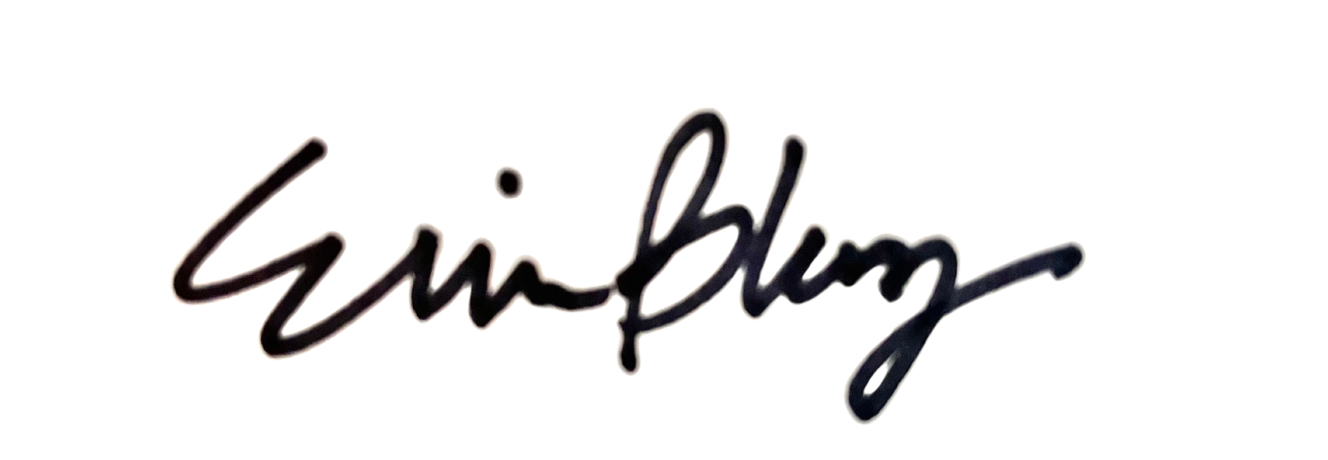

Validated by:

J. Steven Glass, Board Chair
Date approved:

