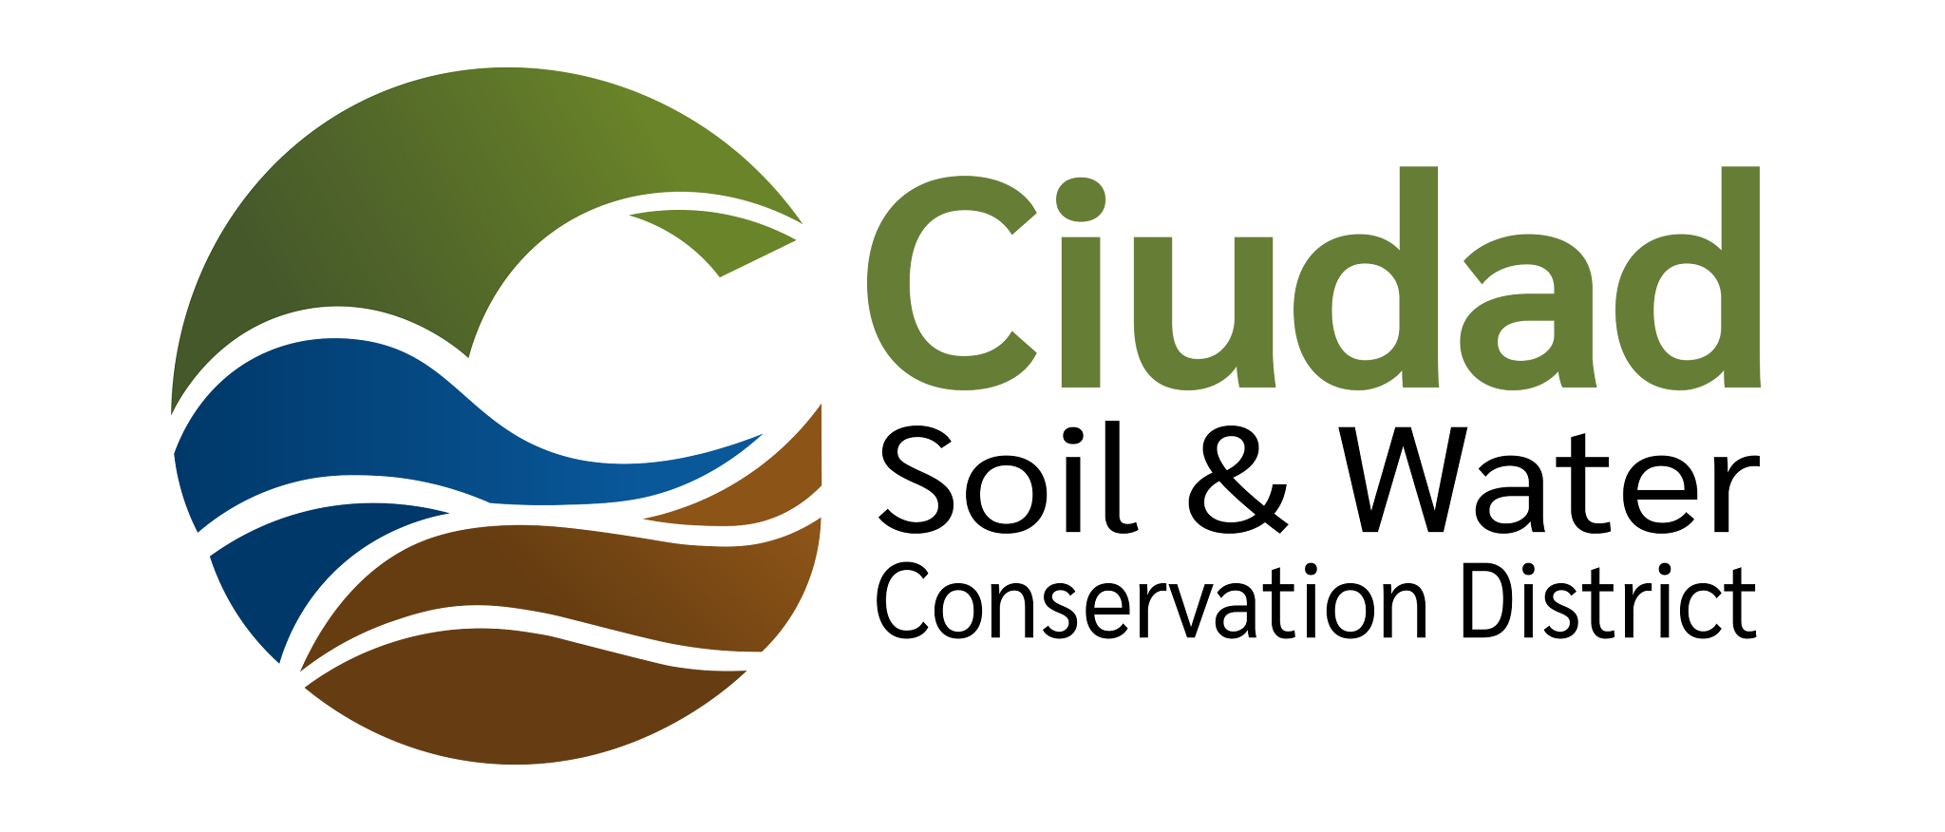
Ciudad Soil and Water Conservation District
1015 Tijeras Avenue NW Suite C
Albuquerque, NM 87102
505-510-3478

CIUDAD SOIL AND WATER CONSERVATION DISTRICT
BOARD OF SUPERVISORS MEETING
Hybrid Meeting

August 17, 2026
Meeting Minutes

- Call to Order 4:37 pm
  - Supervisors present: Attendance confirmed by roll call. A Quorum was present.

Roll call: Steve Glass: Present
Tom Allen: Present
Ramona Goolsby: Absent
Maria Young: Present
Daniel Conklin: Present
Sarah Hurteau: Absent
  - Supervisors Absent: Sarah Hurteau, Ramona Goolsby
  - Others Present: Tammy Silva, Joshua O'Halloran, Erin Blaz, Jennifer Hopper

- Agenda for 8/17/2026 Review and Approval (Action Item): Tom Allen moved to approve the 8/17/2026 agenda. Seconded by Dan Conklin and approved unanimously by roll-call vote.

Roll Call Vote:
Steve Glass: Present
Tom Allen: Present
Ramona Goolsby: Absent
Maria Young: Present
Daniel Conklin: Present
Sarah Hurteau: Absent

- Review and Approval of Minutes (Action Item)
  - Review and Approval (Action Item): Tom Allen moved to approve the Draft Board Meeting minutes for 7.20.26. Seconded by Dan Conklin and approved by roll-call vote.

Roll Call Vote:
Steve Glass: Yes
Tom Allen: Yes
Ramona Goolsby: Absent
Maria Young: Yes
Daniel Conklin: Yes
Sarah Hurteau: Absent

- Guest Presentation:
  - New Staff Introductions

- Public comment: No comments made

- Reports of Partners
  - NMDA (Katie Mechenbier): A written report was provided. SWCC will meet in Las Cruces Sept 15. New Mexico Soil Health Conference in October at Gutierrez Hubbell House Oct 14-15.
  - NRCS (Hector Alvarez): Hector Alvarez introduced himself as the new District Conservationist. A written report was provided and reviewed by Mr. Alvarez
  - NMFD (Eugenio Padilla): No
  - NMACD (Jennifer Hooper): NMACD Annual Meeting coming up on Oct 19-21 at Marriott Pyramid Region 5 is the host District. The Interstate Stream Commission will be presenting too. NMACD received 2 grants. One from USDA for grant training, developing a formal training system for supervisors and employees, employee handbook. Second grant from DFA to provide technical training for the District Board of Supervisors and staff.

- Consent Agenda
  - WUA:Ciudad Backyard Refuge Program MOU. The Water Authority will provide a rebate of $50 certification for Backyard Refuge participants who are Water Authority customers and complete both the Backyard Refuge certification and the lawn to xeriscape conversion rebate program. This rebate is intended to reimburse Water Authority customers for the Backyard Refuge Program certification fee.

Dan Conklin made a motion to acknowledge the completion of this MOU. Seconded by Tom Allen and approved unanimously.

Roll Call Vote:
Steve Glass: Yes
Tom Allen: Yes
Ramona Goolsby: Absent
Maria Young: Yes
Daniel Conklin: Yes
Sarah Hurteau: Absent

- Action Items
  - IGA and 1st Amendment with Albuquerque Public Schools. This IGA establishes partnership between APS and Ciudad SWCD on projects and funding. The 1st Amendment provides funding for a FTE Garden Resource teacher at Polk Academy of Agricultural Science. This position will serve all Polk students (6-8 grade), work with Polk teachers to integrate outdoor learning, agricultural science and culturally relevant garden curriculum into their classrooms and help to advance outdoor learning opportunities and teacher professional development across APS. Tom Allen made a motion to approve Steve Glass’s Signature the IGA and 1st Amendment. Seconded by Dan Conklin and approved unanimously.

Roll Call Vote:
Steve Glass: Yes
Tom Allen: Yes
Ramona Goolsby: Absent
Maria Young: Yes
Daniel Conklin: Yes
Sarah Hurteau: Absent

  - 4th Amendment to TCWRP IGA with BernCo (SG). This extends the term of the existing IGA until June 30 2027. Dan Conklin made a motion to approve Steve Glass’s signature on the 4th Amendment. Seconded by Maria Young and approved unanimously.

Roll Call Vote:
Steve Glass: Yes
Tom Allen: Yes
Ramona Goolsby: Absent
Maria Young: Yes
Daniel Conklin: Yes
Sarah Hurteau: Absent

- Finance Committee (Action Items):
  - Finance Committee Financial Documents. The report was verbally reviewed by Tammy Silva. Still waiting on about half of last year's invoiced reimbursements. The 1st half of the loan from Torrence SWCD has been repaid. The finance team is working on the new and improved estimate vs actuals report. Mr. Glass inquired about the status of Mill Levy payments. Joshua O’Halloran explained the Mill Levy rate has been coded by DFA at $0.25. Dan Conklin recommended that the board accept the report and Tom Allen made a motion to approve the report. Seconded by Dan Conklin and approved unanimously.

Roll Call Vote:
Steve Glass: Yes
Tom Allen: Yes
Ramona Goolsby: Absent
Maria Young: Yes
Daniel Conklin: Yes
Sarah Hurteau: Absent

- Reports of committees and possible Action Items
  - Policy Committee: Approval of new policy handbook, and approval of driver safety policy. Maria Young asked for clarification on compensatory time, the drug free workplace policy. The Board would like to formally adopt the policy and driver safety policy. Tom Allen moved to formally adopt the new employee policy and driver safety policy. Seconded by Maria Young and approved unanimously.
Roll Call Vote:
Steve Glass: Yes
Tom Allen: Yes
Ramona Goolsby: Absent
Maria Young: Yes
Daniel Conklin: Yes
Sarah Hurteau: Absent

  - Personnel Committee: No updates
  - Mill Levy Committee: No updates
  - Government Affairs Committee: No updates.

- District Staff Report
  - Staff Report. Erin Blaz gave a report about the Education Program

- Other Business
  - NMACD meeting costs for Ciudad Board of Supervisors. Mr. Glass inquired about covering the registration cost to send Supervisors to the NMACD Annual Meeting. Jennfier Hopper of NMACD clarified many Districts cover this cost for Supervisors to attend. The District Manager confirmed funding was available if Supervisors wanted to attend.
Adjourned 6:33 PM

Submitted by: Erin Blaz

Validated by:

Date approved:

